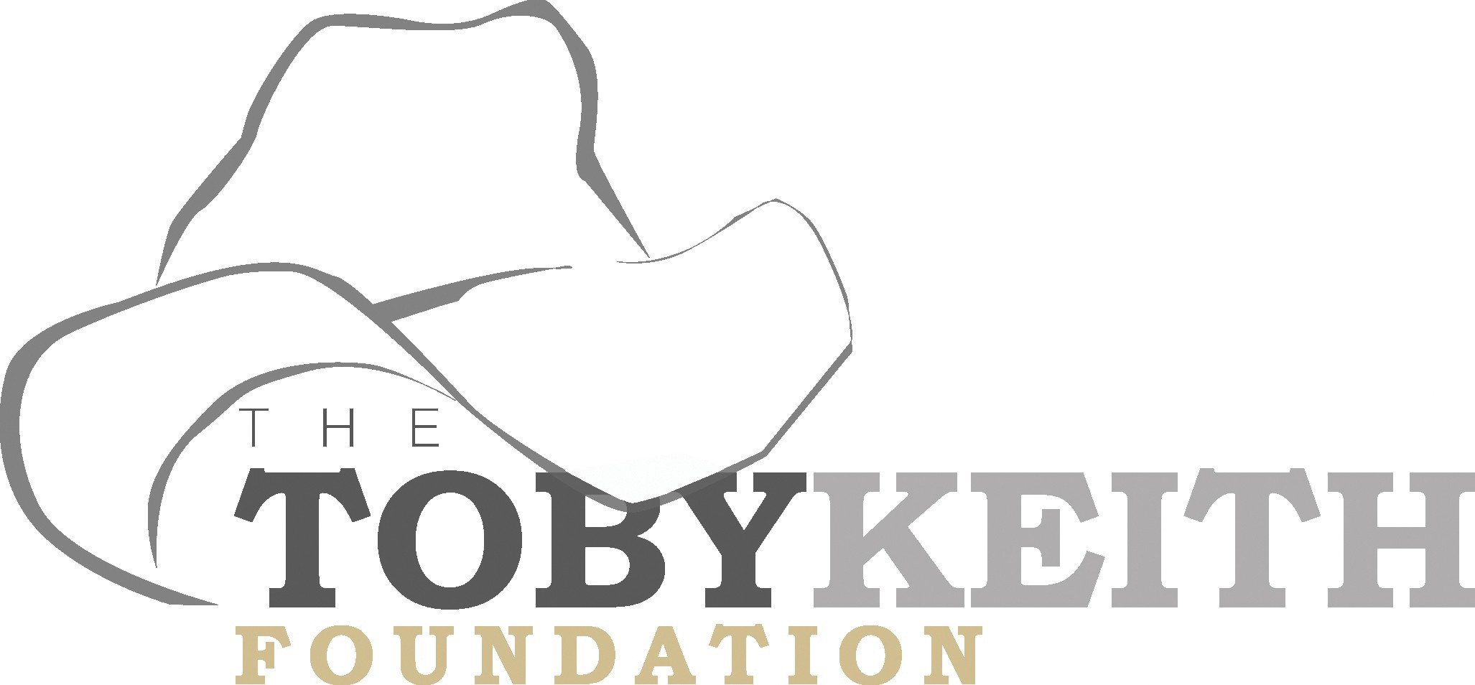

Special Event/Fundraiser Proposal & Licensing Agreement

The mission of The Toby Keith Foundation is to encourage the health and happiness of pediatric cancer patients and to support OK Kids Korral, a cost free home for children and their families to stay while receiving treatment for cancer in Oklahoma City. Since opening our doors in 2014 the Korral has helped alleviate some of the financial, physical and emotional toll of traveling to treatments and has allowed families to focus on getting their child well.

The Toby Keith Foundation appreciates your interest in holding a fundraising event to help us make a difference in the lives of these children. Please fill out this proposal form and indicate your acceptance of the terms and conditions herein by returning a signed copy to us. If the proposal is approved, we will send you a fully signed copy, at which time your license to use The Toby Keith Foundation and OK Kids Korral names will become effective.

Sponsor and Event Information
Name of event:

Address:

Phone: Fax: E-mail:

Name of contact person: Phone:

Date and location:

Briefly describe the event (Attach an additional sheet if necessary):

List of Sponsors: ________________________________________________________________
What participation or resources, if any, do you request from The Toby Keith Foundation?

Do you plan on publicizing the event? Yes No [If “yes” please pay particular attention to Paragraphs 4-6 in the Terms & Conditions Section]

Budget Information
Will admission fee be charged? Yes No If so, how much? $

What % or amount of the fee will The TK Foundation receive?

Will the event generate other types of revenue and, if so, what % or amount of that revenue will The TK Foundation receive?

Anticipated total revenues: $

Anticipated total expenses: $

Anticipated total donation to The TK Foundation: $

Terms and Conditions

- Sponsor agrees to provide The Toby Keith Foundation with all of the net proceeds from the event, along with a written accounting of event revenues and expenses (and supporting documentation for any expenses in excess of
$500), in a form acceptable to The Toby Keith Foundation, within thirty (30) days after the event. The Toby Keith Foundation may audit the event revenues and expenses, if necessary.

- The Toby Keith Foundation is the owner of certain federally registered and common law trademarks, service marks and trade names and the hat logo (collectively, the “Marks”). If (and only if) this proposal is approved by The Toby Keith Foundation, Sponsor will be granted a non-exclusive license to use the Marks in connection with the event.

- The term of the license granted hereunder shall be from the date The Toby Keith Foundation approves Sponsor’s proposal until the conclusion of the event; provided, however, that The Toby Keith Foundation has the right to terminate the license if it determines, in its reasonable discretion that the event is or will likely be injurious to the Marks.

- Any use of the Marks is subject to the prior written approval of The Toby Keith Foundation, Sponsor agrees to submit to The Toby Keith Foundation for approval – prior to the production, distribution, broadcast, or publication thereof – all printed materials, publicity releases and advertising relating to the event that mentions The Toby Keith Foundation or contains the Marks. If there are errors in the use of the Marks, the sponsor agrees to reprint items with no expense incurred by The Toby Keith Foundation.

- Sponsor understands and agrees that the Marks: (a) may not be altered in any way, nor may they be sublicensed to any other person; (b) may not be used in connection with any telemarketing or door-to-door solicitations; and/or (c) may not be used in conjunction with terminology that is contrary to The Toby Keith Foundation’s mission. Sponsor further acknowledges that, it may not solicit cash or in-kind donations from persons via the Internet or have The Toby Keith Foundation associated with any provocative pictures or materials.

- In accordance with standards adopted by the BBB Wise Giving Alliance, Sponsor agrees that any solicitations relating to the event must specify at the point of solicitation, and in a manner acceptable to The Toby Keith Foundation: (a) that The Toby Keith Foundation is the benefiting organization; (b) the actual or anticipated portion of the purchase price that will benefit The Toby Keith Foundation; (c) the duration of the campaign; and (d) any maximum or guaranteed minimum contribution amount.

- In order to avoid inadvertently jeopardizing existing relationships between The Toby Keith Foundation and its donors, Sponsor agrees to receive approval from The Toby Keith Foundation before soliciting corporations, businesses, celebrities, sports teams, or individuals for cash or in-kind donations relating to the Event.

- Sponsor represents to The Toby Keith Foundation that: (a) it will comply with all applicable laws during the planning, promotion and conduct of the event; (b) all necessary insurance, licenses and permits will be obtained and will be in force through the conclusion of the event; (c) the event will result in no cost or expense to The Toby Keith Foundation whatsoever, unless expressly agreed in writing to the contrary; and (d) it will indemnify and hold The Toby Keith Foundation harmless from any and all claims of any kind or nature whatsoever arising out of, or in any way related to, the event.

- Nothing in this document shall be construed to authorize Sponsor, or any of its employees or representatives, to act as an agent of The Toby Keith Foundation. Thus, for example, Sponsor may not open a bank account in The Toby Keith Foundation’s name, nor may it endorse or attempt to negotiate any checks made payable to The Toby Keith Foundation, all of which must be promptly forwarded to The Toby Keith Foundation for processing.

-------------- I understand and accept all of the above terms and conditions. (Initial)

This Special Event Proposal and License Agreement will not become effective unless and until it is approved by The Toby Keith Foundation, as evidenced by the signature of an authorized The Toby Keith Foundation executive director below.

PROPOSED BY: APPROVED BY:

Signature of authorized representative Signature of Executive Director of Sponsor of The Toby Keith Foundation

Print name Print name

Date Date
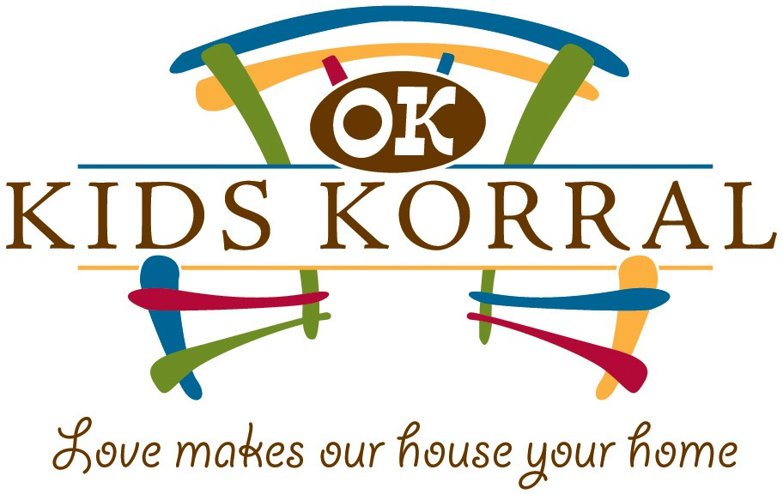

Please return signed form to: The Toby Keith Foundation
Attn: Community Relations 818 N.E. 8th Street Oklahoma City, OK 73104

